Task 2 - Operations on sample data

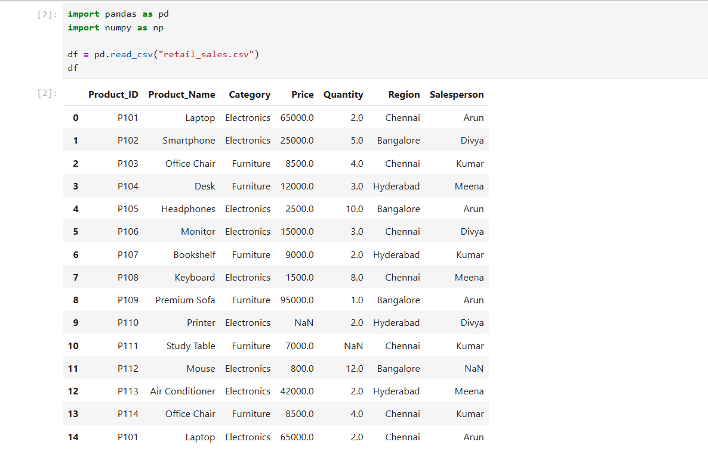
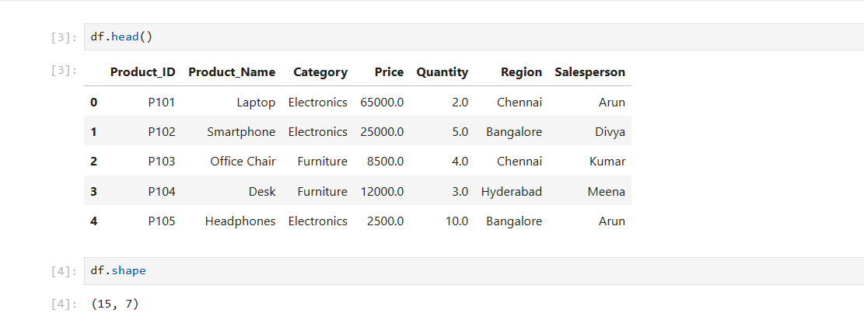
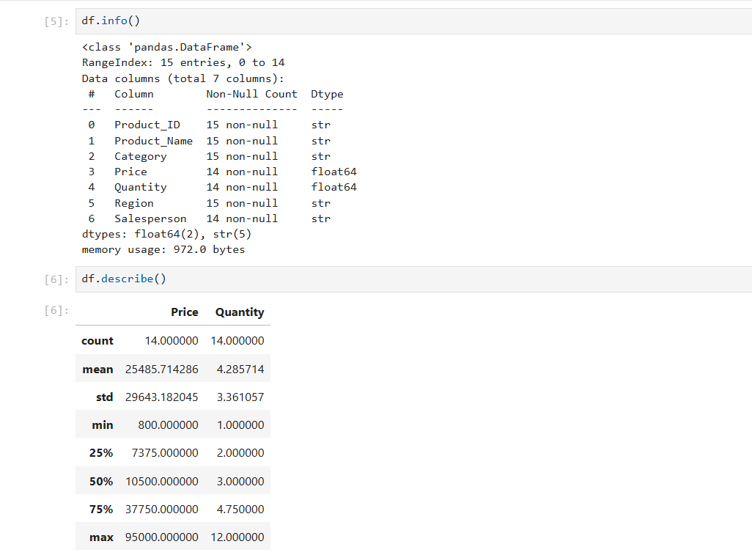
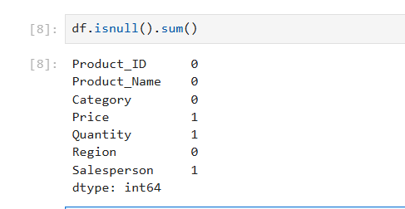
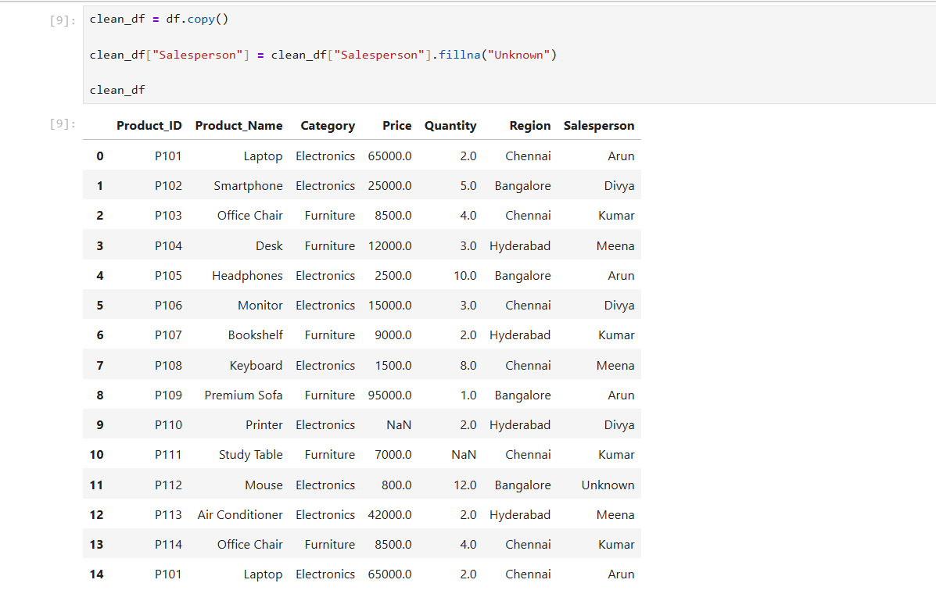
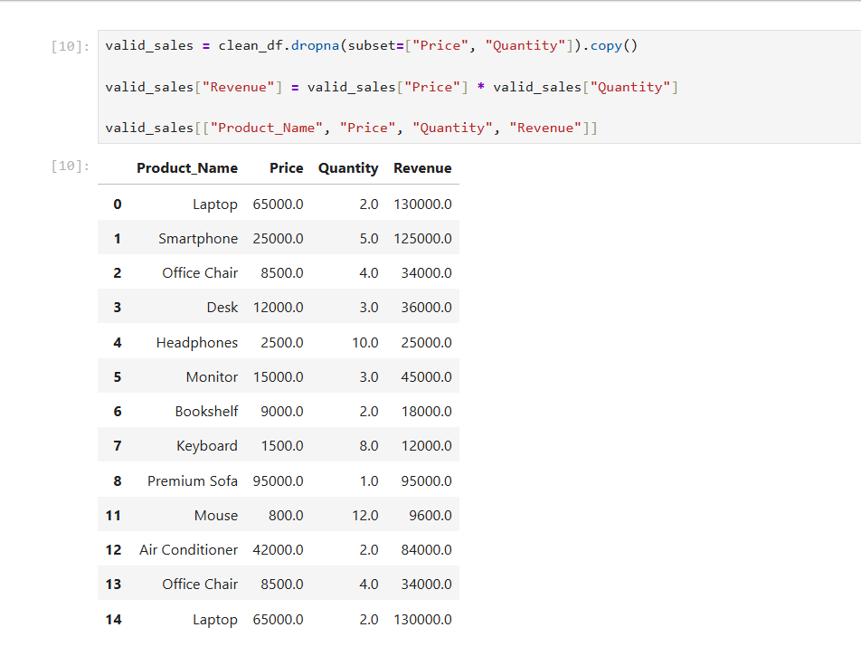
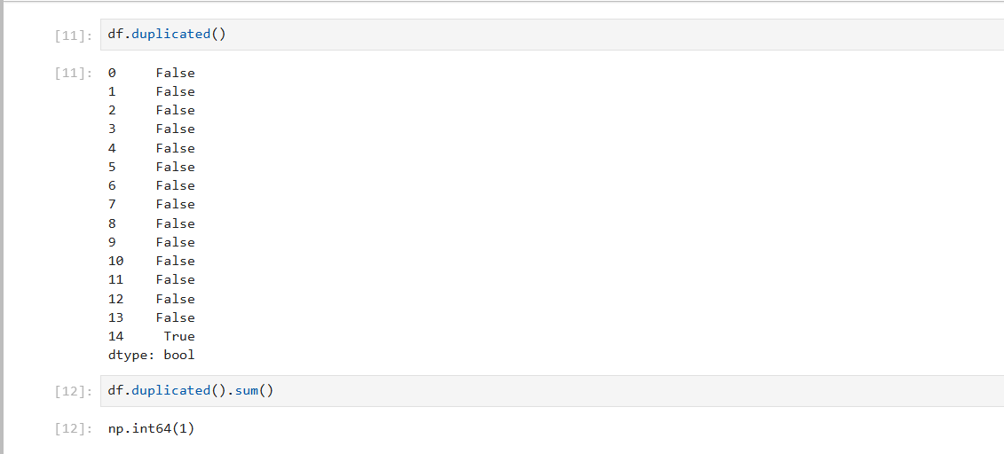

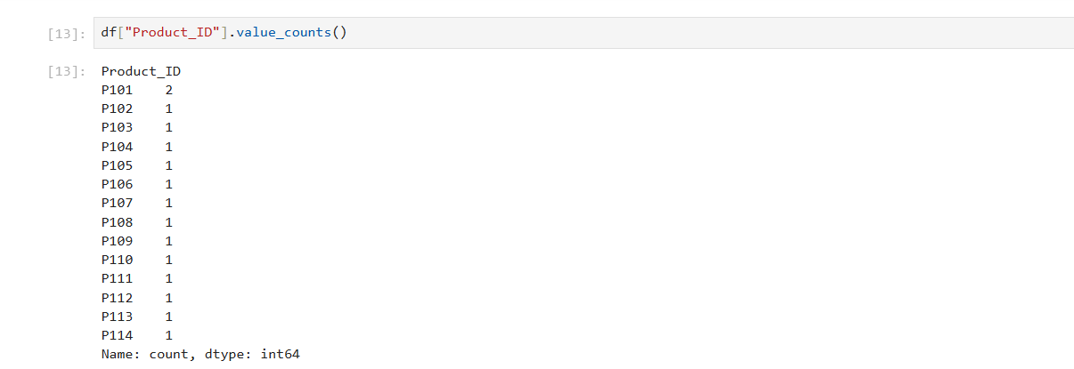
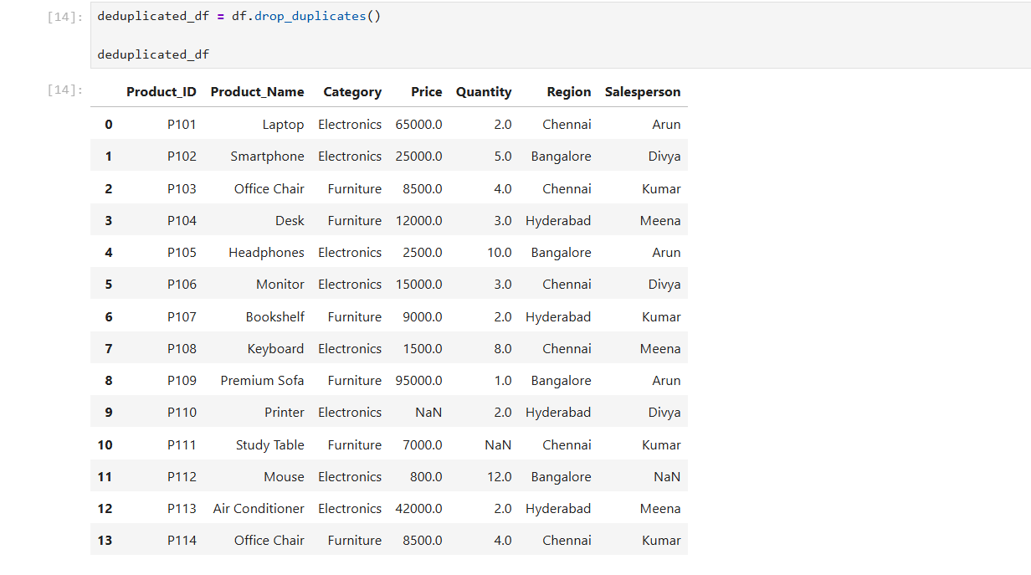
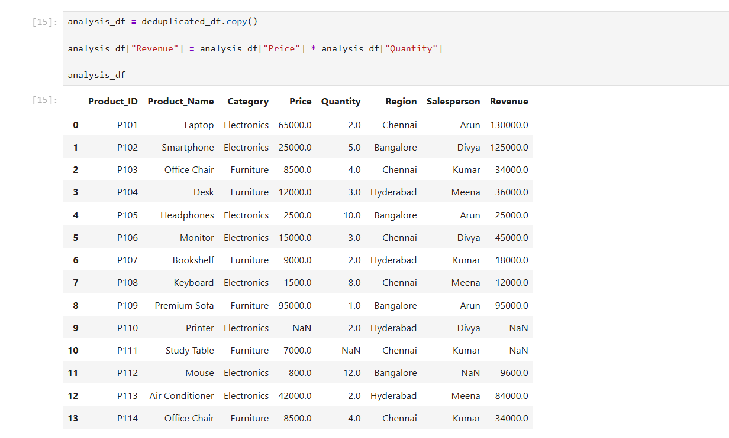
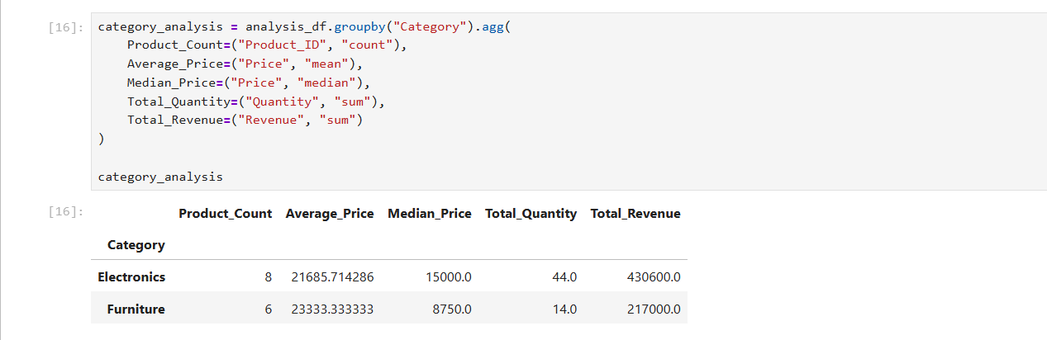

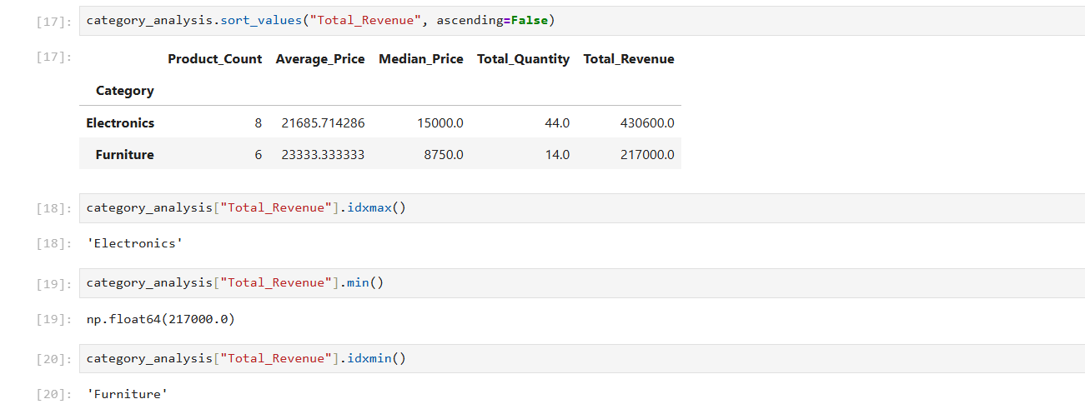
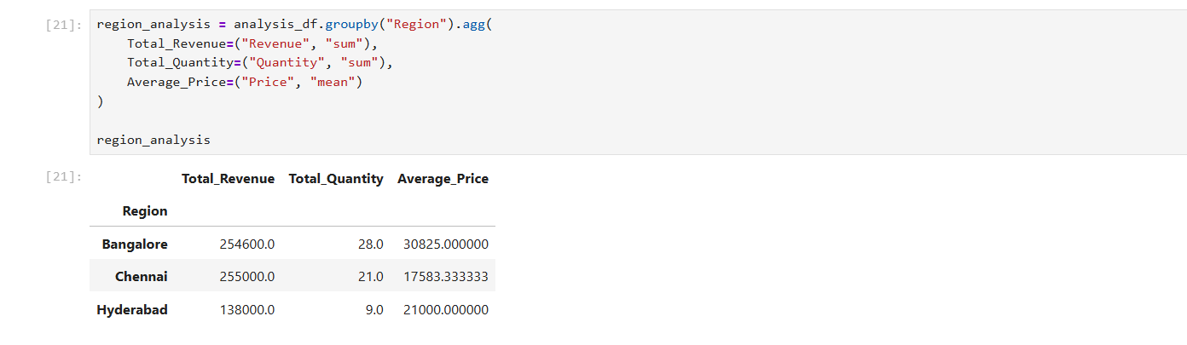

- Number of missing values in columns
Cause:
- Price may not have been entered during product billing.
- Quantity may have been missed during data entry.
- Salesperson details may not have been recorded by the system.
Solution:
- Make important fields mandatory when entering sales data.
- Check invoices to recover missing prices and quantities.
- If the salesperson is unknown, fill the missing value with "Unknown".

2. Duplicate values
Cause:
- The same sales record may have been imported twice.
- A transaction may have been submitted more than once.
- The system may not have checked for existing records before saving new data.
Solution:
- Verify duplicate records against the original sales transactions.
- Remove confirmed duplicate records using drop_duplicates().
- Use a unique transaction ID to prevent the same transaction from being recorded twice.

3. Highest-priced products
Cause:
- The product may use premium materials or have special features.
- Supplier costs may be high.
- The price may have been entered incorrectly, such as adding an extra zero.
Solution:
- Verify the price against the product catalogue and supplier invoice.
- Compare the price with similar products in the market.
- Set reasonable price ranges and flag unusually high prices for review.

4. Group revenue by city or region
Cause:
- Customer demand may differ between regions.
- Some regions may sell more expensive products.
- Product availability and marketing activities may vary by location.
- Missing data or duplicate records may affect revenue calculations.
Solution:
- Compare revenue and quantity sold for each region.
- Increase marketing in regions with lower sales after investigating the reasons.
- Ensure products are available where customer demand is high.
- Clean missing and duplicate records before making business decisions.

